[Procedure Title]
Other than the headings and the Meta Data Document Management table in section 8, all other text is for guidance only and should be removed from the final procedure.
- Headings and styles for use
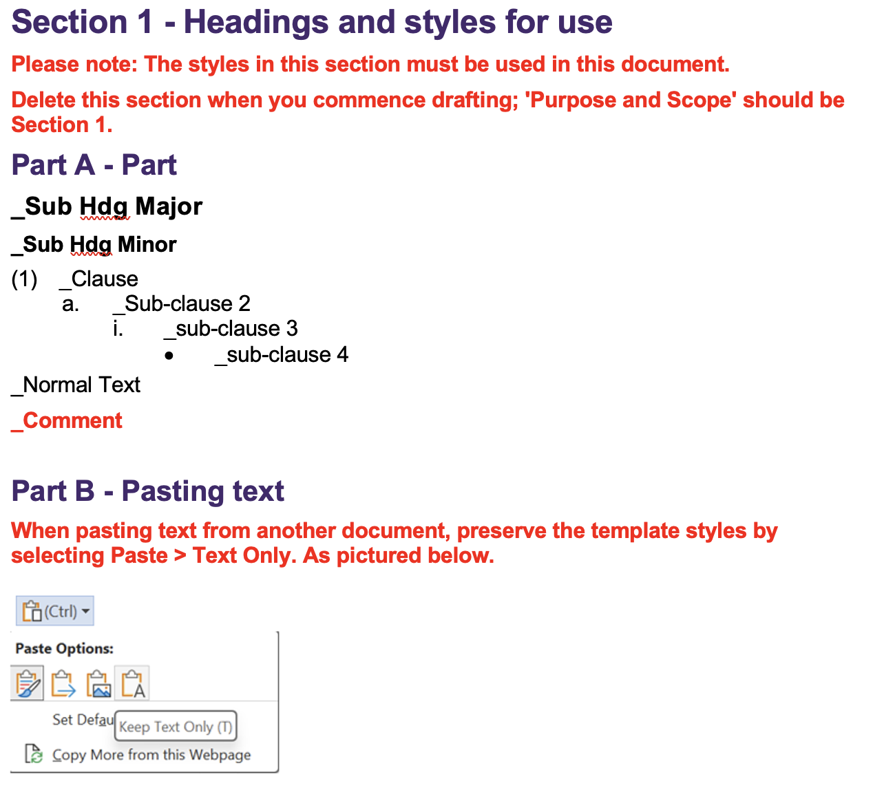
- Purpose and Scope
- State the objective/s of the procedure and which policy it relates to, scope of the subject matter covered; to whom the procedure applies and any important exclusions.
- The information given in this section should be sufficient to demonstrate the importance of the procedure and why it is mandatory.
- Process and Key Controls
- Highlight the important controls and their specific location in the process.
- Key Requirements
- Given the purpose and scope of the procedure, and its parent policy, provide an overview of the process covered by the procedure, and state the major activities and actions required.
- If process is presented as a flowchart or diagram, it may be better included as an appendix.
- [NOTE: Generally Policy requirements state WHAT needs to be achieved (outputs and outcomes/end goals) and WHY; Procedure requirements state HOW they need to be achieved and WHEN].
- The key requirements must clearly align with the objectives of the procedure and the actions required must be verifiable.
- This is the most important section of the Procedure, hence each and every requirement should be able to withstand any close scrutiny or robust challenges.
- The requirements should be stated with precision, be concise, action-oriented and their underlying merits so obvious and convincing to the audience that there is a very high degree of acceptance and compliance.
- Avoid unnecessary or cumbersome impositions on the University.
- Roles, Responsibilities and Accountabilities
- Articulate the responsibilities and accountabilities of the key roles affecting or affected by this procedure (those involved in the development, implementation and management of the procedure).
- The responsibilities and accountabilities should be stated in simple, easy to understand terms and be action oriented (i.e. what needs to be done and who needs to do it).
- Monitoring, Review and Assurance
- Ensure that it is clear what monitoring and review activities will be undertaken and by whom to:
  - Assess compliance with the procedure and to demonstrate/confirm its effectiveness.
  - Identify, assess and promptly address any deficiencies.
  - Ensure ongoing relevance of the procedure.
- Recording and Reporting
- Specify how and where the transactions, activities and results associated with this procedure will be recorded and who would be responsible for the integrity of the records and information.
- Also specify what reports will be produced, by and for whom to demonstrate that the objectives and outcomes warranted by this procedure are being achieved.
- Appendix
- If deemed necessary, use the appendix to:
  - List terms and acronyms used in the procedure and their definitions. If only a few terms and acronyms are used, they may be listed and defined in the body of the procedure, as appropriate.
  - Provide additional information necessary for the reader to better understand the procedure.
  - Ensure any appendices, including mandatory forms, are properly referenced in the procedure.
- Meta Data for Document Management
Correct meta data must be supplied for the document to be published and to enable effective document management.
Metadata
Associated Information
(e.g. links and explanations)
Area of responsibility | [e.g. Directorate, School, Business Unit, etc]
Policy Owner | [Position]
Unit Head
(person reporting to responsible executive)
Document Author
(person writing the document)
Enquiries contact
(at business area level,
if different from area of responsibility)
Document Category | Select applicable from list
Document Realm | Select applicable from list
Target Audience  (select all applicable) | ☐ Staff | ☐ Students | ☐ Community
Next review date  (generally five years from approval date unless required sooner) | [list frequency of review cycle, e.g., 3 years, 5 years; or, list particular date if applicable]
Change summary
Amendment summary
(Briefly describe the changes – this commentary will be visible to all PPL users)
Consultation outcomes
(where undertaken)
Issues of note
(where applicable)
Other Notes

Overall
- Ensure the procedure passes all of the following tests:
  - It will enable prudent and timely decisions to be made and for University operations to be performed effectively and efficiently.
  - It focusses on delivering specific outputs and outcomes in a competent manner.
  - It provides clarity of roles, responsibilities and accountabilities.
  - It adopts a holistic and risk-based approach to the design and implementation of controls and for demonstrating compliance.
  - It enables, or at least does not restrict, automation and the innovative use of technology.
  - It incorporates management assurance protocols to monitor, assess and ensure that documented controls are effective, efficient, current and continuously improved.
  - It is based on the approved document template for procedures and written in simple and easy to understand language.
- Also ensure the drafted procedure sufficiently demonstrates its importance and makes a compelling case for its existence as a stand-alone mandatory document.

