Appendices

Appendix A: Barricading selection requirements
Type | Access Conditions & Applications | Types of Barricades | Examples
Caution | Access permitted; caution required. The caution tape is to be used to highlight hazards to other personnel that may need to access the area. Any person may access into a caution barricaded area, if they have familiarised themselves with the hazards detailed on the barricade signage and implemented any controls indicated on the signage. This tape is not appropriate for medium, high or extreme risk hazards e.g. unprotected edges, falling objects, electrical hazards. |  | Wet floor or surface  Keep off grass after pesticide spray
Restricted Access/ Danger | Access permitted under instruction and authority given from the CFM/Supervisor detailed on the signage. The restricted access tape restricts access to the barricaded work area. Only personnel authorised by the Supervisor are permitted to enter. This barricade is suitable to use to restrict access from hazards such as:  - Hot work  - Persons working above / falling objects  - Spills/leaks  - Unprotected edges creating a fall risk of less than 500 mm  - Over 500 mm may be used to delineate a hard barrier | 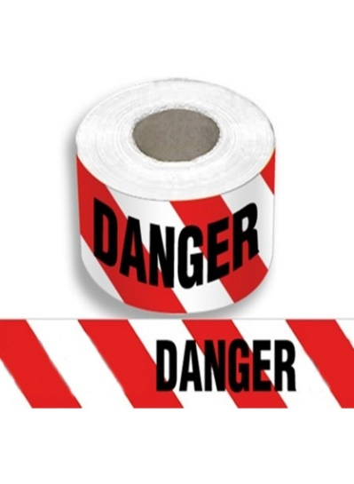 | Hot Work  Confined spaces  Falling objects near EWP or ladders etc.  Minor Repairs  Risk of exposure to toxic chemical
Restricted Access/  Electrical Work | Used to barricade off and restrict access to electrical hazards. This tape is commonly used for switchboard maintenance.  Only the work party and personnel authorised by the CFM in charge of the barricaded area are permitted to access through the barricade.  Danger tape with appropriate signage can also be utilised. | 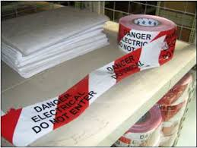 | Electrical work of any type  Electrical hazard  Damaged wires etc.
Radiation | No access for unauthorised persons. Can be erected by site first response personnel and/or investigation team. This tape is erected to secure an incident scene. | 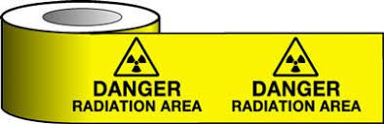 | Used for Radiation hazard area
First Incident Response Scene | No access for unauthorised persons. Can be erected by site first response personnel and/or investigation team.  This tape is erected to secure an incident scene. |  | Used in case of any accident or incident to secure and protect the incident site
Barrier Mesh and Bunting Flags | Barrier mesh and bunting flags are high visibility soft barricading options where a solid barricade is not required. May be used in conjunction with appropriate barricading tape and signage to delineate work areas that require authorised access or used to highlight the boundary of a work area. | 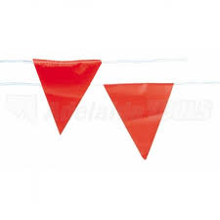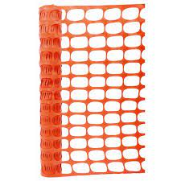 | Used to secure the work areas from the pedestrians and public access  Event management  Forklift or crane operations
Solid/Hard barriers e.g. Jersey, Expandable Barriers, Scaffolding Equipment | Hard barrier control options include but are not limited to:  Jersey type barriers  A modular device used to segregate areas where plant and equipment is being operated and as a traffic safety control.  The barrier is established to maintain a safe distance that segregates pedestrians and workers from plant and equipment. Where a risk assessment determines that the barrier system is required to provide physical protection such as to deflect an out-of-control vehicle, the barrier shall meet the design criteria of relevant Australian Standards e.g. AS/NZS 3845:1999 Road safety barrier systems.  Expandable barriers  Free standing, portable hard barrier option.  Scaffolding equipment  Where the barrier is required to perform the same function as a permanent handrail/guardrail, the barrier shall meet the design criteria of relevant Australian Standards e.g. AS/NZS 4994.1:2009 Temporary edge protection – General requirements. | Jersey Type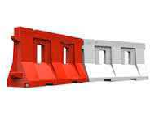  Expendable Barrier  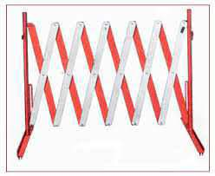  Scaffolding Barrier Edge Protection  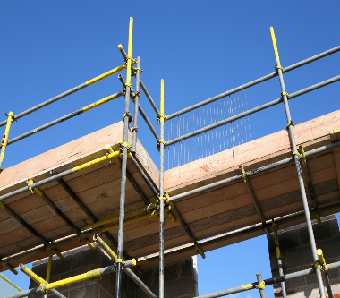 | Deep excavations  Mobile plant operation  Heavy traffic area  Construction sites using mobile equipment  Renovation sites  Demolition sites  Working at Height protection  Edge protection
Cones/Bollards | Used to demarcate an area containing a hazard as a substitute for caution tape.  - Must always be accompanied by signage  - Application must be included in JHA/JSA  - In circumstance where the hazard persists for more than seven days, then site supervisor must assume responsibility for checking the ongoing integrity of the cone demarked area, or barricade must be installed. |  | Used with barrier tape, caution tape, other tapes and signage

Appendix B: Appropriate signage for barricading
All barricades shall be fitted with signage at appropriate spacing intervals along the barricade to ensure the signage is visible from all entry points. The following table indicates the type of signage that is appropriate for each type of barricade. It is to be noted that signs may not be the same as the signs shown below.
Type of Barricade | Examples of Signage
Caution Barricade Tape (soft barricade)  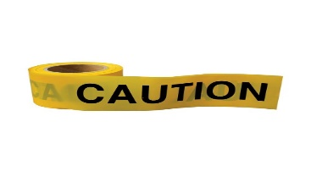 | 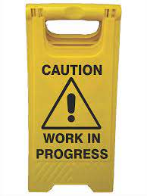
Danger Tape (soft barricade)  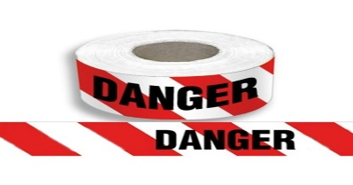 | 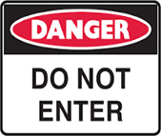
Restricted Access Electrical Work Barricade Tape (soft barricade) | 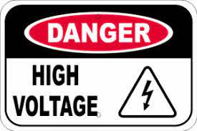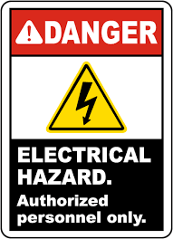
Restricted Access (hard/solid barricade) | 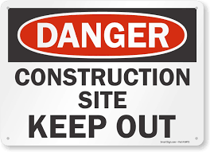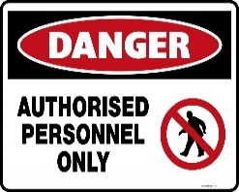

Appendix C: Types of safety signs commonly used on site
Type | Requirements | Example
Prohibition Sign | An action or activity is not permitted | 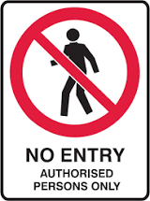
Mandatory Sign | An instruction must be carried out
Limitation Sign | Defined limit on an activity
Danger Sign | Indicate imminent risk of injury to a particular hazard or hazardous situation that is likely to be life threating if ignored | 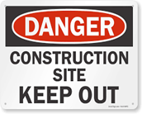
Warning/Caution Sign | Indicate potential risk of injury due to a particular hazard or hazardous situation that is not likely to be life-threatening

